**FPT Aptech, 590 Cách Mạng Tháng 8, Quân 3, Thành phố Hồ Chí Minh**

**X-STAR CINEPLEX**

**Cinema website**

**Installion Guide – Semester II**

|  |  |  |
| --- | --- | --- |
| **Supervisor:** | Mr. Cat Nguyen Hieu Tuan | |
| **Semester:** | II | |
| **Batch No:** | T1.2008.E1 | |
| **Group No:** | 1 | |
| **Order:** | **Full name** | **Roll No.** |
| 1. | Le Tuan Xuyen | Student1275055 |
| 2. | Tran Pham Thanh Hoang | Student1275235 |
| 3. | Nguyen Nhat Nam | Student1275240 |
| 4. | Phung Van Phuc | Student1277217 |

**PROJECT: X-STAR CINEPLEX**

**GROUP NO:1, BATCH: T1.2008.E1**

1. **System Requirement**

|  |  |  |
| --- | --- | --- |
| **Sr.** | **Item** | **Description** |
| **1** | **Operating system** | **Windows 7 or higher** |
| **2** | **Database** | **MySQL** |
| **3** | **Web Server** | **XAMPP 7.3** |
| **4** | **PHP** | **Version 7.0 or higher** |
| **5** | **LARAVEL** | **Version 5.0 or higher** |
| **6** | **Software** | **Visual Studio Code (IDE)** |
| **7** | **Web browser** | **Microsoft Edge, Chrome, Firefox** |

1. **Installation Guide**

**STEP 1: *Download the project file from google drive to your computer***

- Right click on the .rar file and select extract file (Figure 1).

- Then, the following foders will appear: (Figure 2)

+ Database

+ X-StarProject

- Copy two folder(Database and X-StarProject) to xampp's htdocs directory(Figure 3).

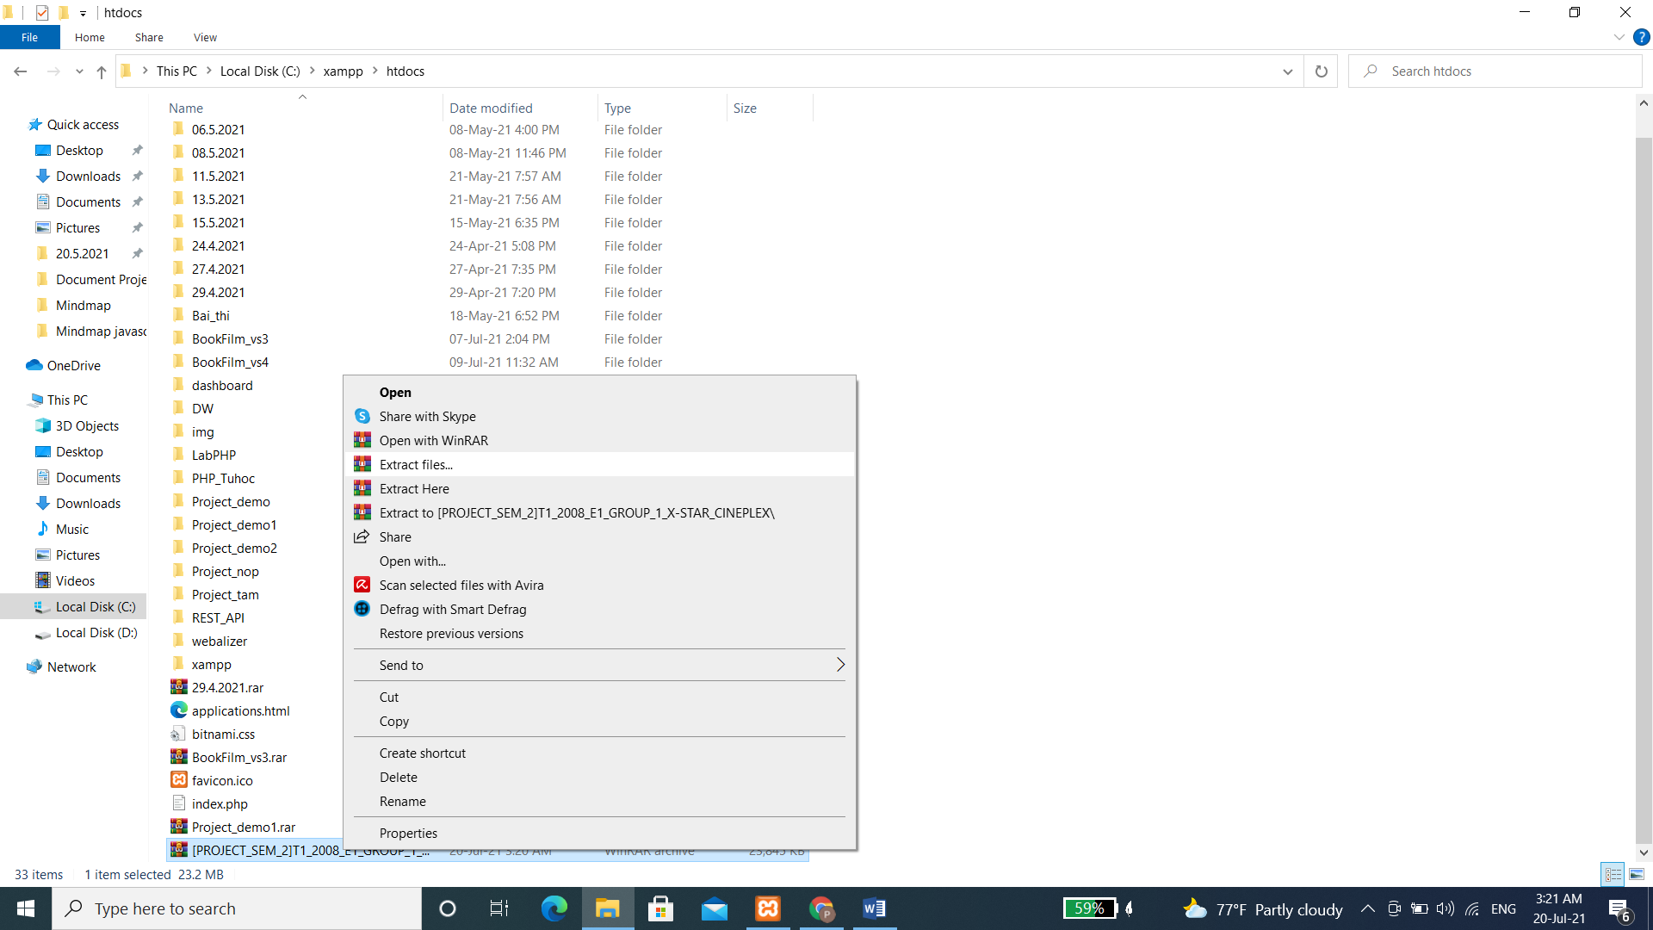

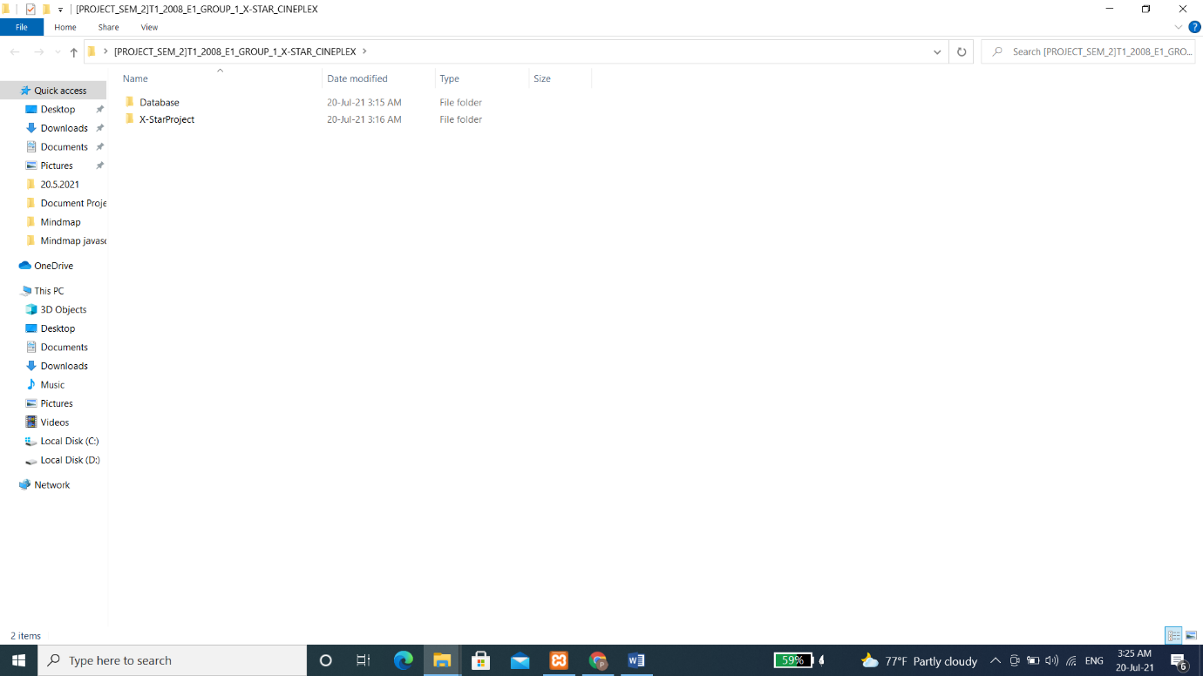**Figure 1**

**Figure 2**

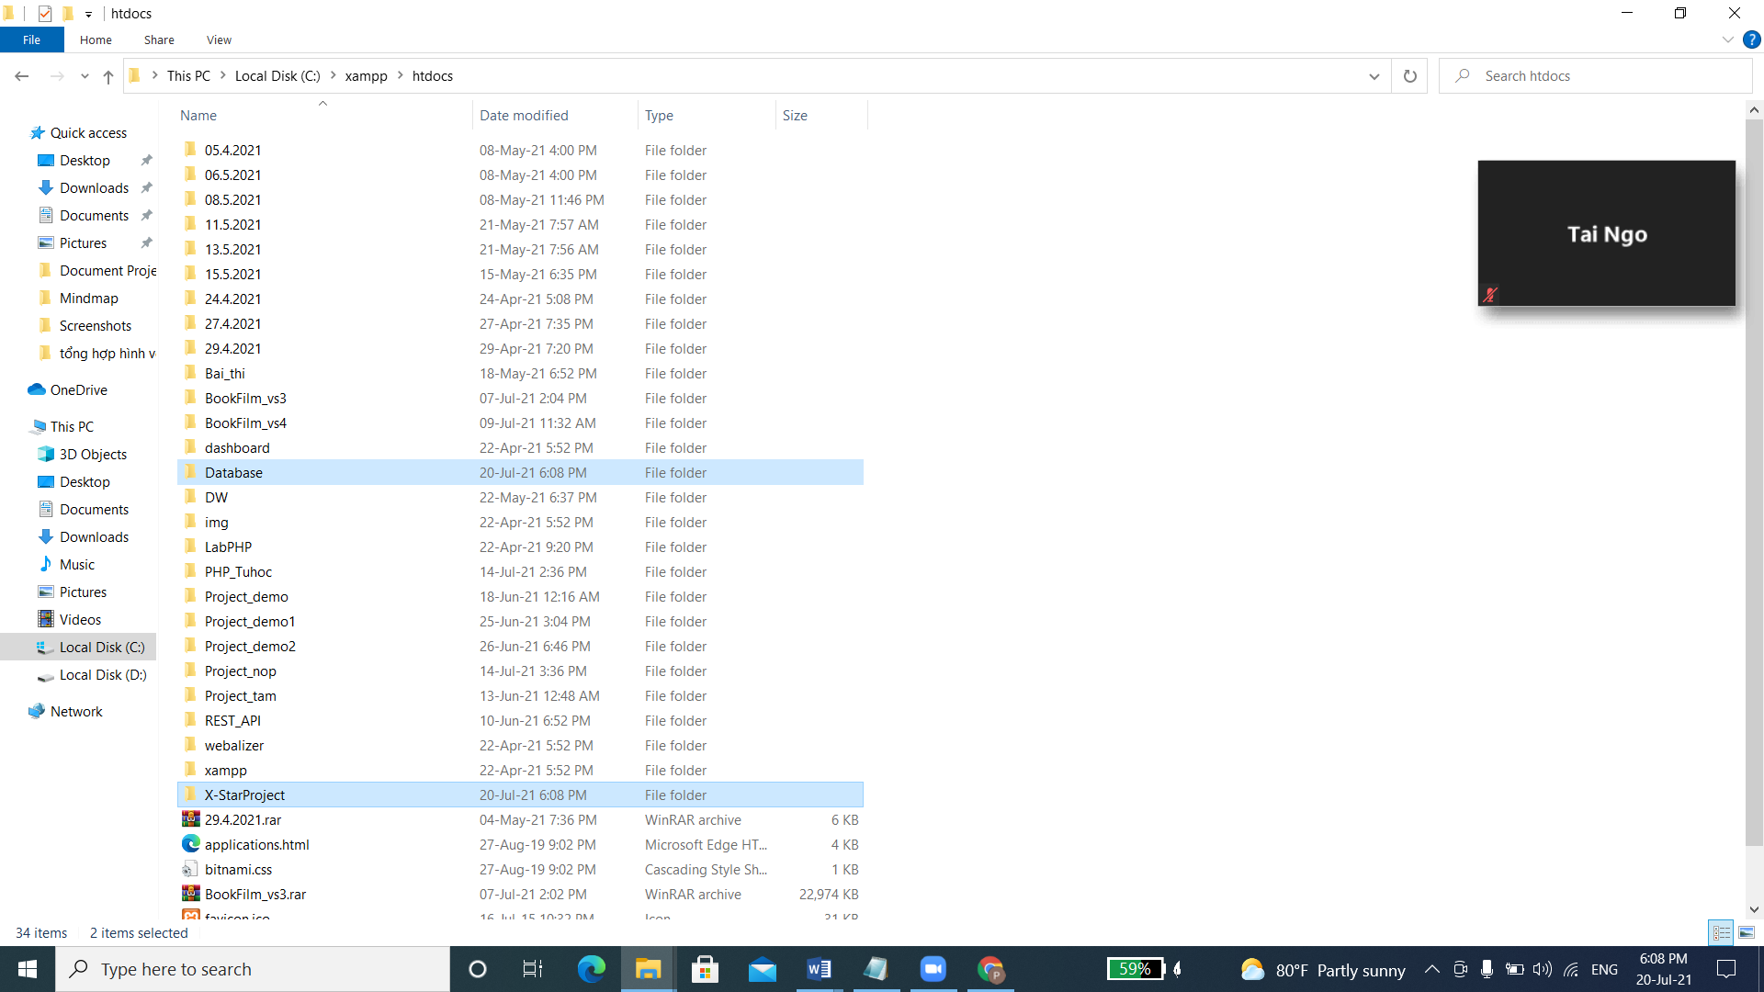

**Figure 3**

**STEP 2: *Activating the XAMPP’s server***

- Open file xampp-control.exe in xampp foder (Figure 4)

- When the Control panel appear, click Start modules Apache and MySQL (Figure 5)

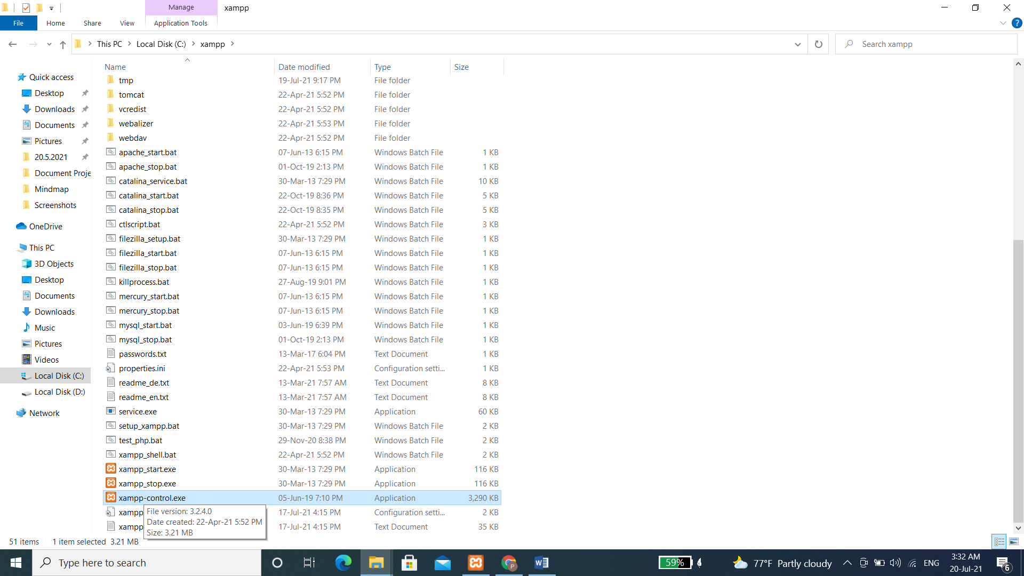- It will connect to <http://localhost/phpmyadmin/>

**Figure 4**: Double click vào xampp-control.exe

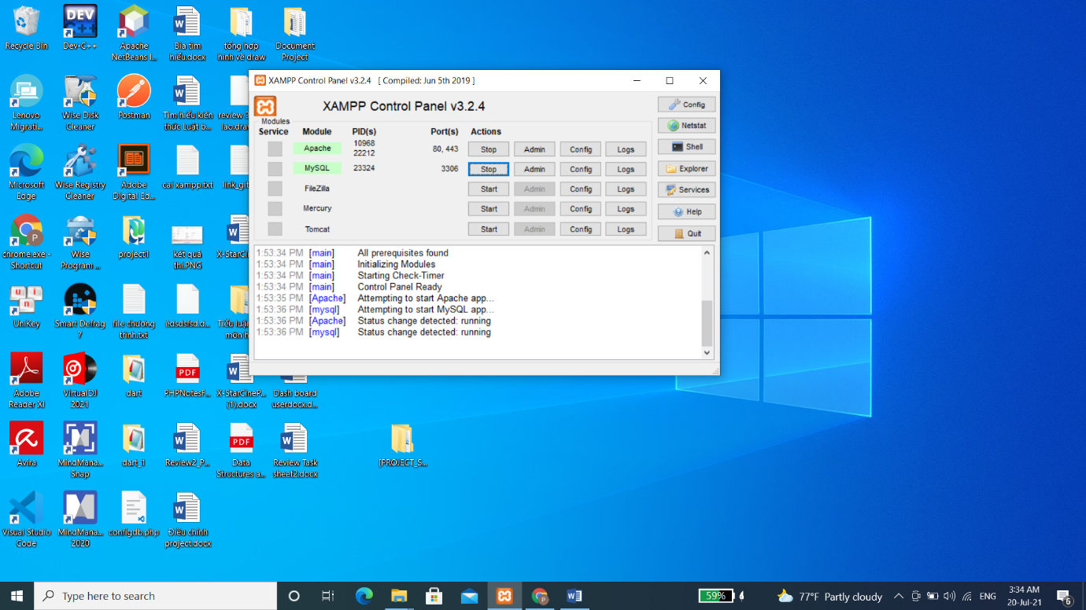**Figure 5**

**STEP 3: *Setup bookfilm database in MySQL***

* Create database bookfilm and import data into it by following the instructions in the figure below (Figure 6, 7, 8, 9)

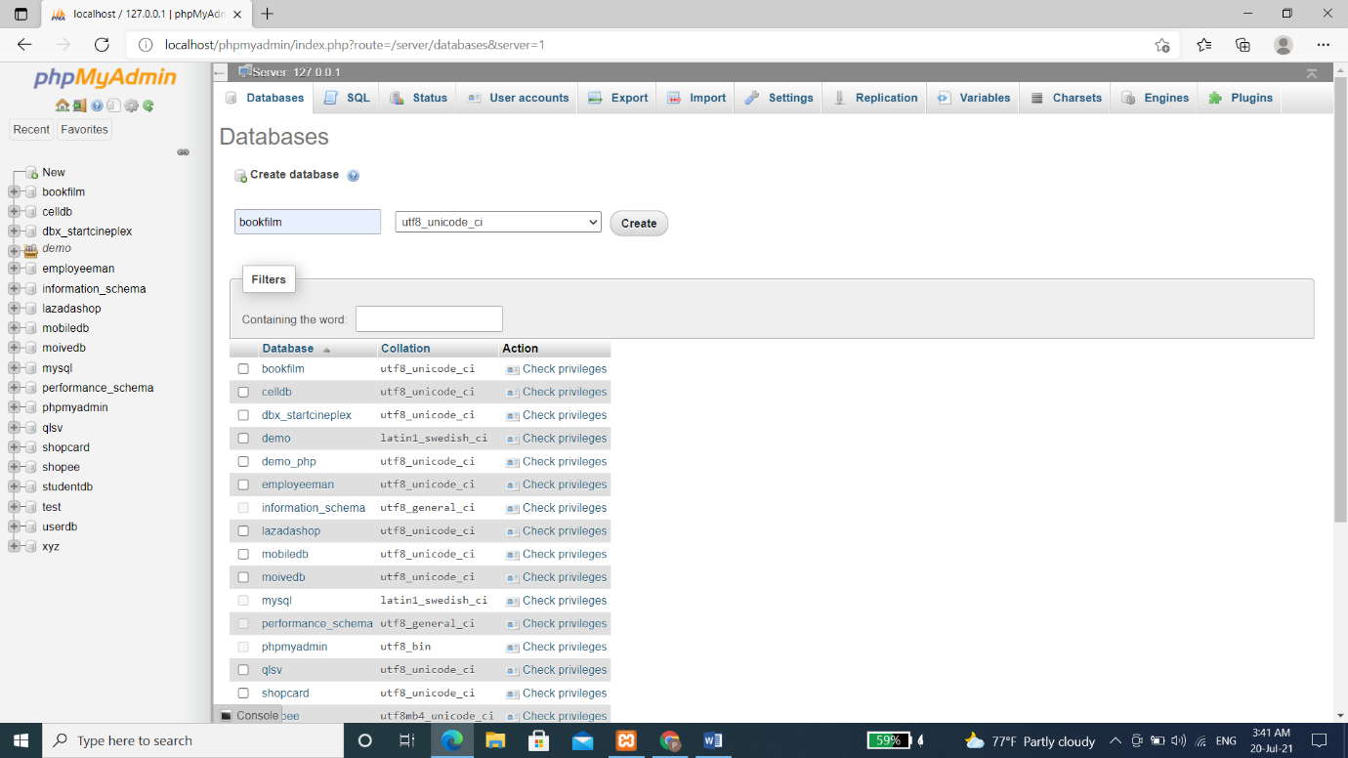**Figure 6:** Create database bookfilm

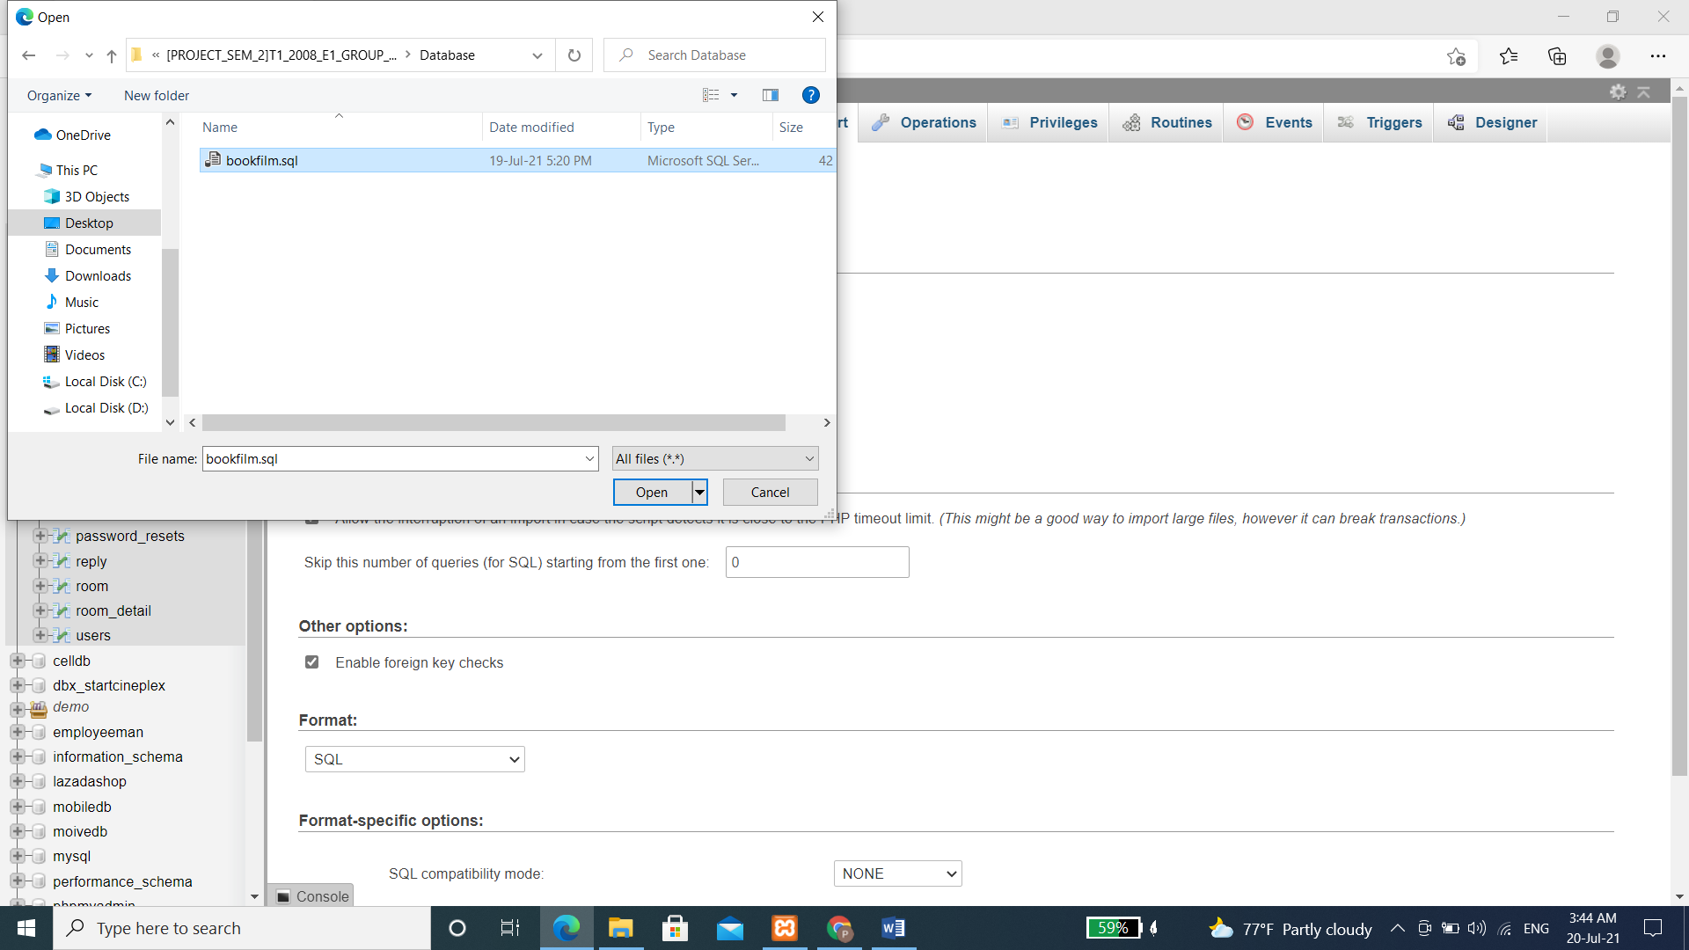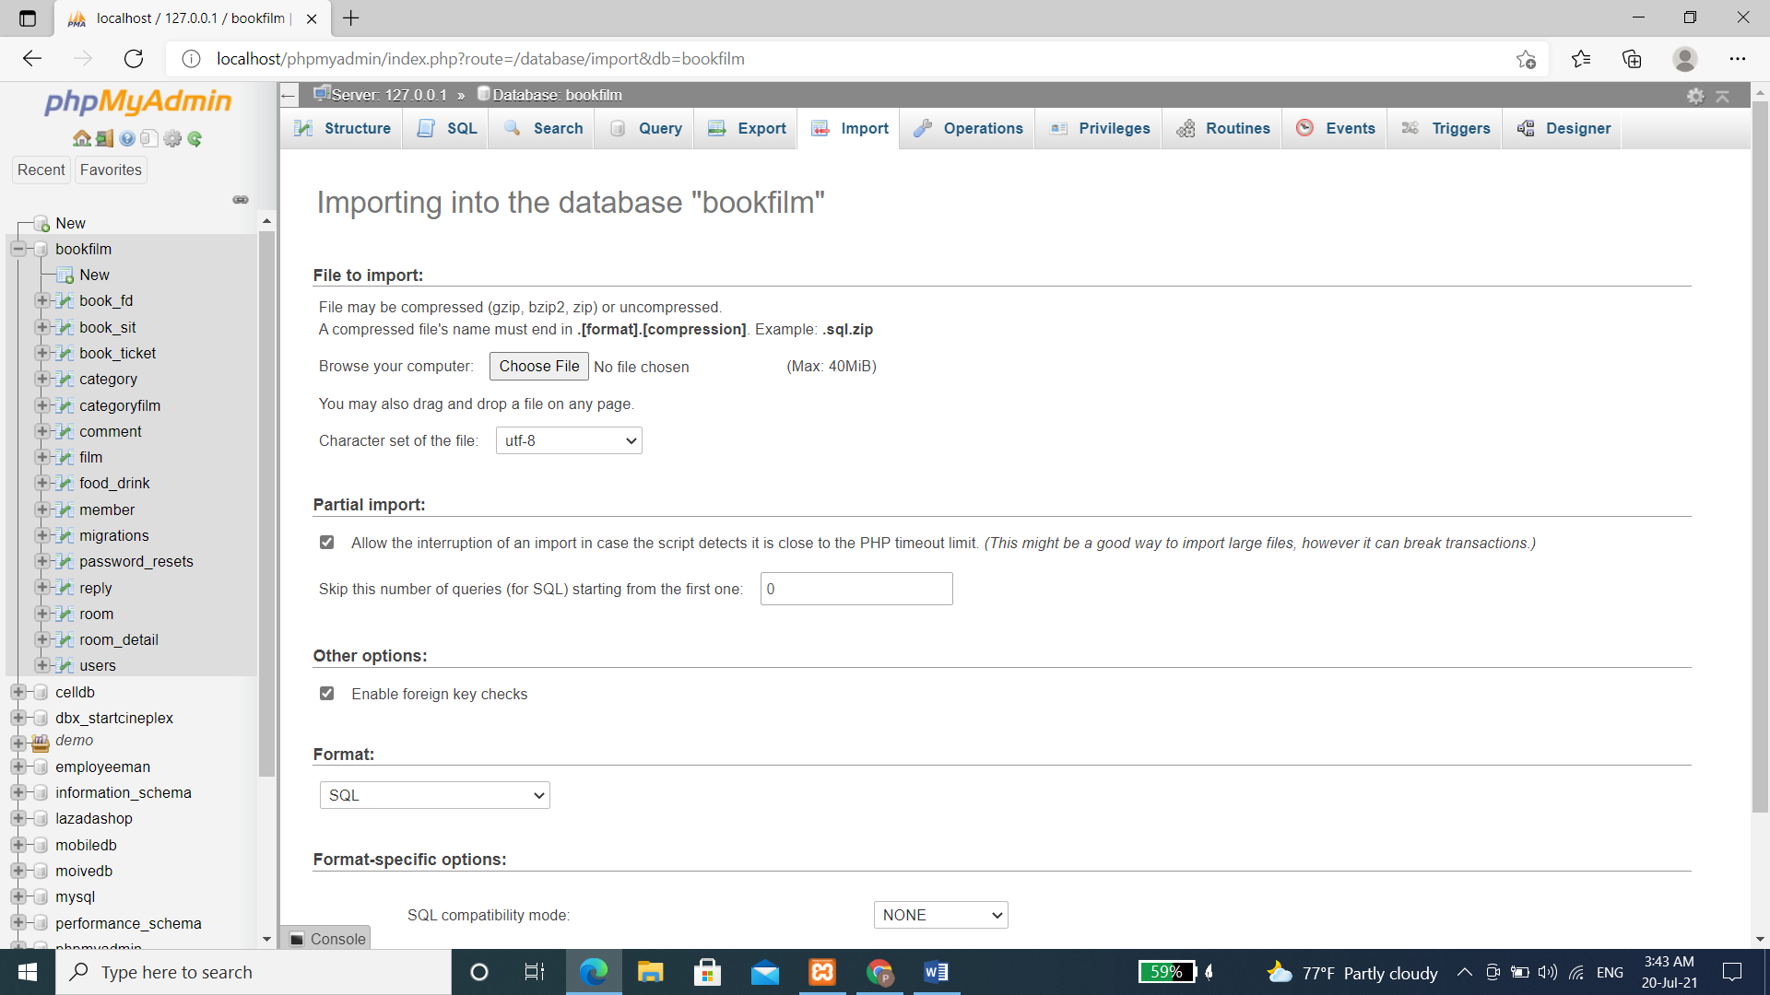**Figure 7:** Import bookfilm database by click Choose File button

**Figure 8**: Choose file bookfilm.sql in database folder and click go to import data

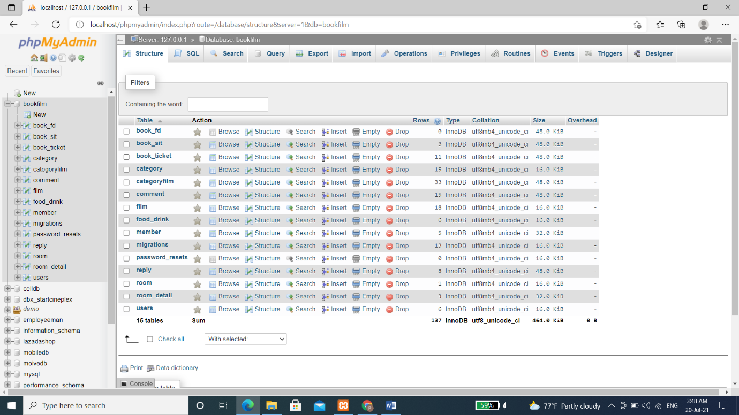**Figure 9:** Click on the bookfilm database to check whether all the tables are imported successfully.

**STEP 4: *Open project X-StarProject***

- Open Visual Studio Code. If this software is not installed yet, please download it via this website: <https://code.visualstudio.com/>.

- Click File then choose Open Folder(Figure 10)

- Choose X-StarProject folder in htdocs folder, click Select Folder (Figure 11)

- After that click on Terminal and choose New Terminal (Figure 12)

- Input into terminal command line: php artisan serve (Figure 13)

- When message “Laravel development server started: <http://127.0.0.1:8000>” appear, open your browser, click on the following links to access the X-Star Cineplex admin website and user website.(Figure 14)

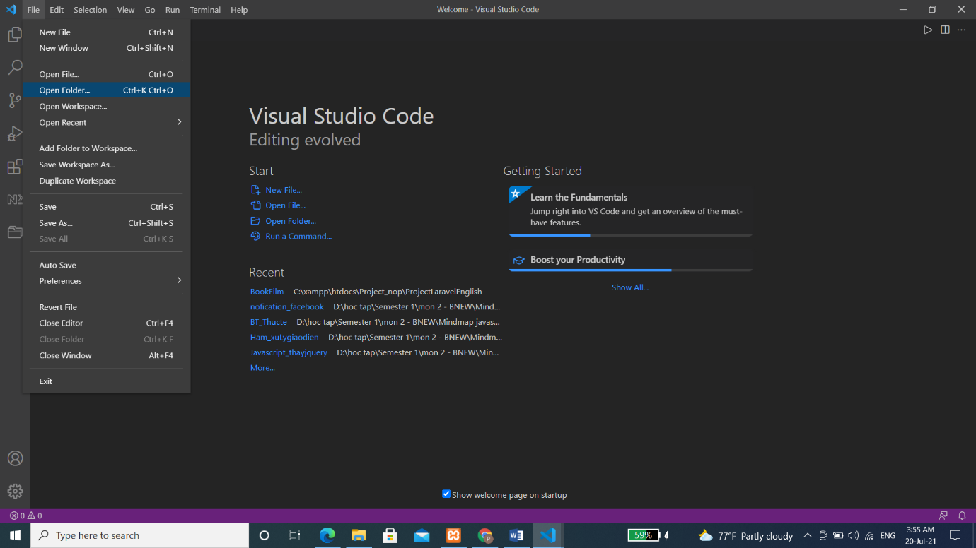**Figure 10**

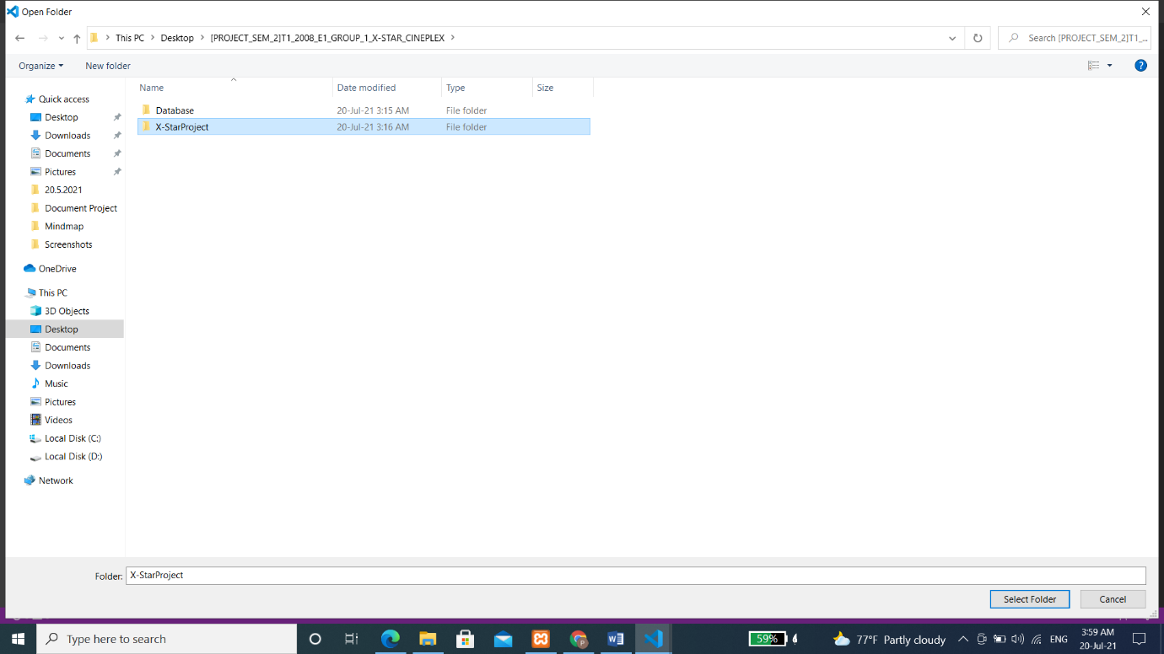

**Figure 11**

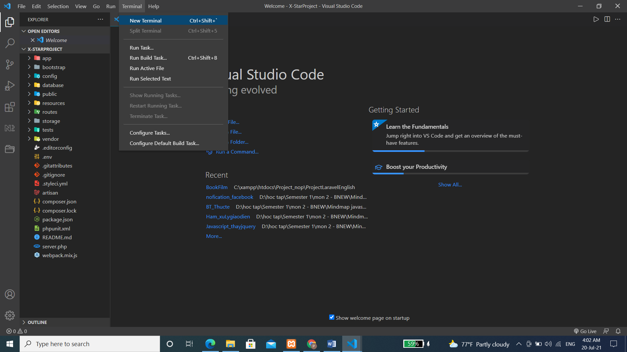**Figure 12**

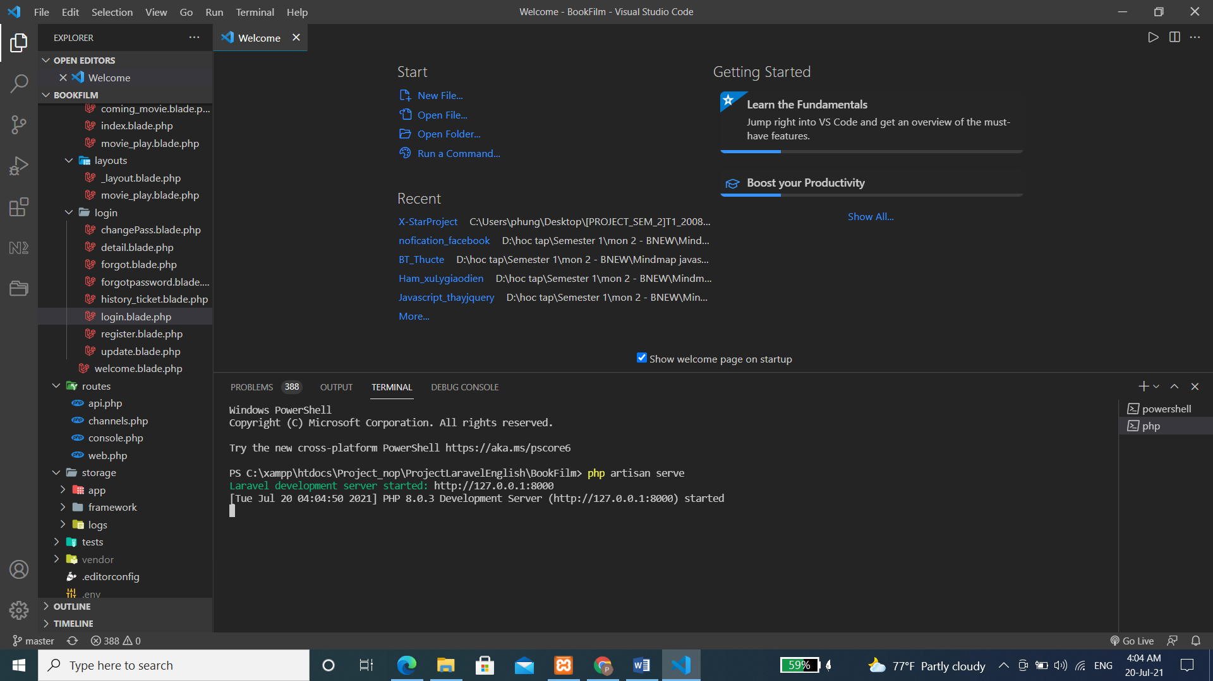

**Figure 13**

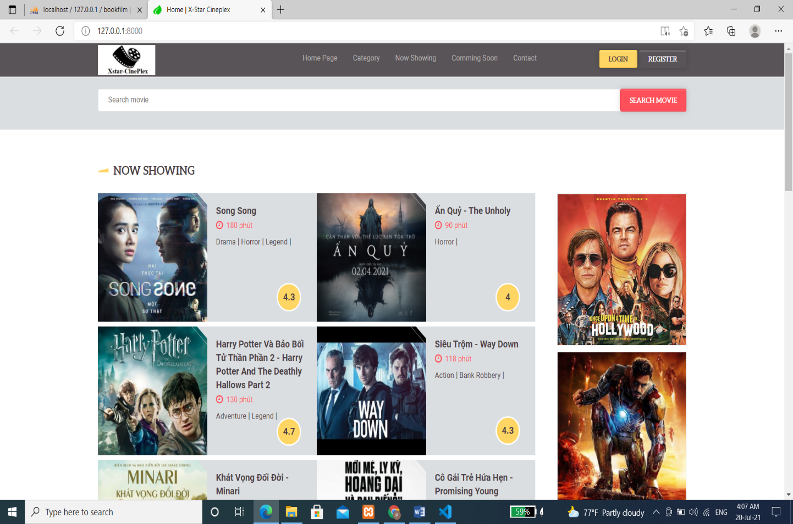**Figure 14**: User website: <http://127.0.0.1:8000>

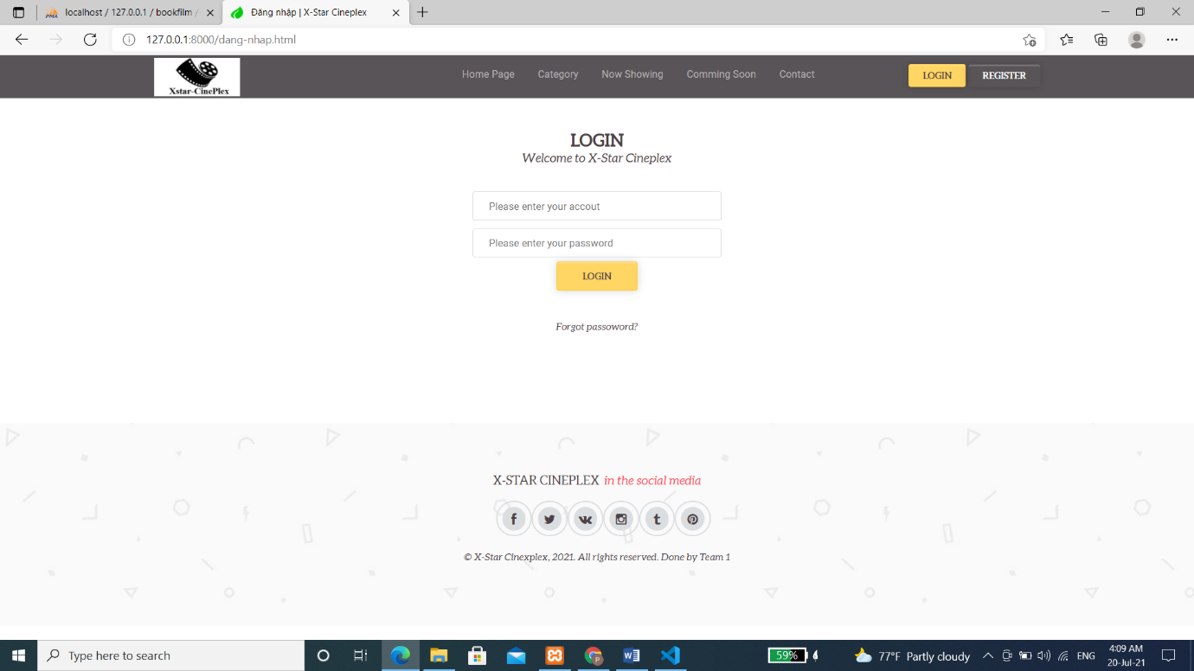**Figure 15**: Click Login and input (account: admin, password: 123456) to login admin website

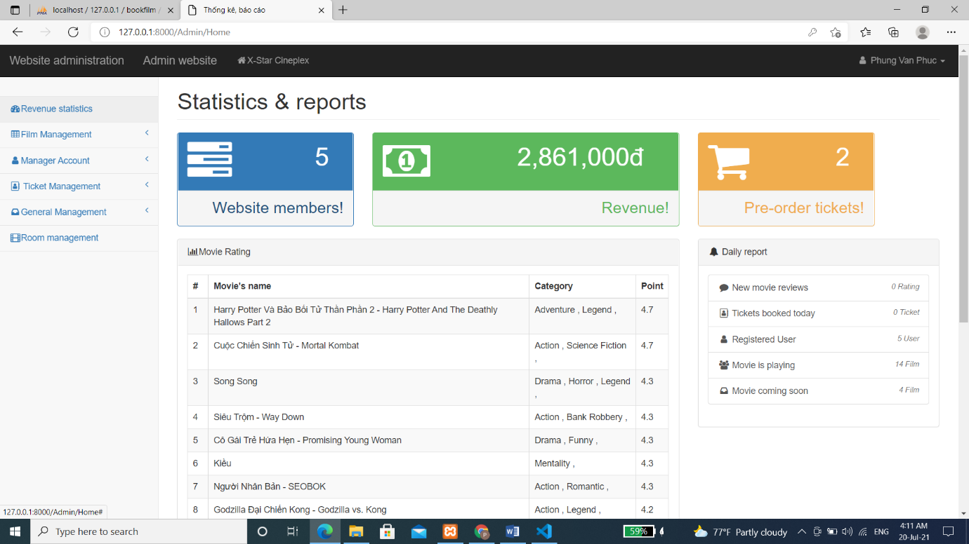

**Figure 16**: Admin Webiste will show when click login

--------The End--------